Father and son spew hate at CA immigration rally; after video goes viral, son loses scholarship
https://www.dailykos.com/stories/2018/7/19/1781931/-Father-and-son-spew-hate-at-CA-immigration-rally-after-video-goes-viral-son-loses-scholarship?detail=emaildkre
Jessica Sutherland Daily Kos Staff Thursday July 19, 2018 · 2:08 PM EDT
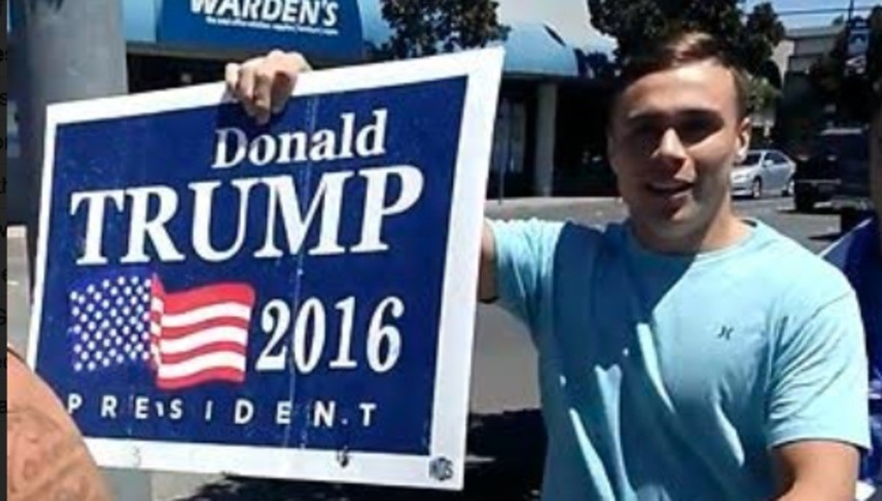
A young Trump supporter from central California has lost his wrestling scholarship after being caught happily spewing hate on camera, alongside his father and a friend. On June 30, Bronson Harmon, 18, pictured above, showed up as counter-protesters to the Modesto #FamilesBelongTogether rally with his father, Todd, and an unnamed friend. After the event ended, an attendee encountered the screaming father-son-friend trio, and whipped out his phone.
Abdul Lasaing, who recorded the video, said he heard the men shouting as they approached so he pulled out his cell phone.
“I not once said anything to these guys, I was just walking,” Lasaing told The Tribune on Wednesday. “I’m not sure if I was disrespected for my skin color or my “World Peace” sign. I was shocked.”
Lasaing said he was scared because one of the men, Todd Harmon, was wearing gloves and looked like he was there to fight.
Just as the video begins, Papa Todd can be heard shrieking “Send their asses back!” Apparently unwilling to disappoint his father, the younger Harmon, who knows he’s being filmed, shouts “Fuck you, faggot!” at Lasaing. Bronson then flips him the bird, while a still-unnamed friend smiles for the camera.
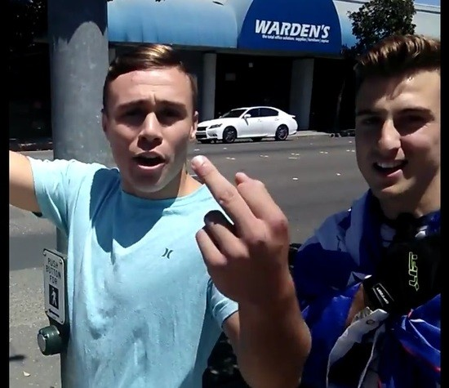
Look how happy they are.
Presumably, the Harmons and Bronson’s buddy headed home to do whatever racists do after a long day of hate mongering. Meanwhile, Lasaing uploaded the video to Facebook; as of this writing, it’s been viewed over 41,000 times. In another video, posted to Twitter but since deleted, the younger Harmon was recorded shouting “Take pictures of this! Trump 2020!” The family was later involved in a physical altercation, according to Modesto Police Department spokesperson Sharon Bear.
According to Harmon, he saw a man placing a screwdriver behind the tire of his father’s truck as they were getting ready to leave. The man, who later filed a complaint with police, said he saw the screwdriver and was trying to pick it up to prevent a flat tire.
Bronson and the others confronted the man and allegedly pushed him, according to the complaint, and he fell against a tree and scraped his arm. There was a small amount of blood on his arm and clothing, but he refused medical assistance at that time, Bear said. The victim asked to press charges. Harmon told The Tribune he never touched the man.

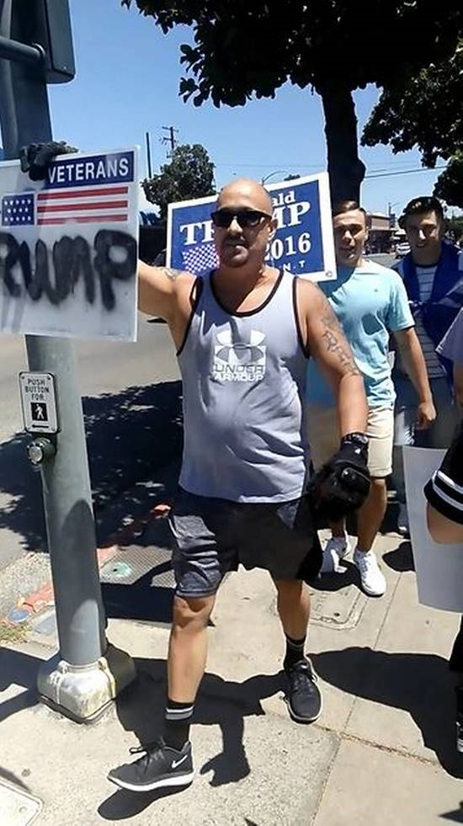
Remember, hatred is taught. Also, wearing gloves in summer is a strange, scary choice, Todd.
Just three days later, on July 2, Jon Sioredas, the wrestling coach at California Polytechnic State University in San Luis Obispo, called Harmon and told him his wrestling scholarship had been revoked. Cal Poly Athletic Director Don Oberhelman refused to discuss the decision in-depth but did tell The Tribune that the video had been viewed by school officials before the scholarship was rescinded.
Oberhelman said the offer of financial aid signed by all student athletes says the university can cancel aid for actions that could cause embarrassment to the school at the discretion of the athletic director.
As of Tuesday, Harmon, who was one of the Golden State’s top-ranked wrestlers, still plans to attend the university, and focus on his dreams of being a mixed martial arts fighter. He also expressed something slightly resembling regret, with a healthy scoop of First Amendment victimhood.
“Saying what I said is definitely not the right thing. I am supposed to be there to help the community be the best person I can be and represent the college the best way I can,” Harmon told The Tribune on Tuesday. “But I still feel like my freedom of speech was taken away, and I don’t think my scholarship should have been revoked over something like that.”

The district attorney is reviewing the complaint against the Harmons; as of Tuesday, no charges were filed, and nobody has been arrested.
Lasaing, meanwhile, told The Tribune that he feels bad that Harmon lost his scholarship. Sort of.
“I do believe there is consequences for your actions,” he said. “I hope he gets all the help he needs.”
Predictably, the Harmon family has lawyered up, and but not just to cry “freedom of consequences.”
Todd Harmon declined an on-camera interview but told CBS13 since the videos were posted Cal Poly San Luis Obispo has revoked Bronson Harmon’s scholarship, and the family is devastated. They have hired an attorney and they are considering filing a lawsuit over violation of First Amendment rights.
Modesto Police confirm they have recommended a misdemeanor battery charge be filed against Harmon for allegedly shoving a man into a tree after the protest had ended.
Friday, Jul 20, 2018 · 7:52:33 PM EDT · Jessica Sutherland

